POM-681 BUSINESS ANALYTICS AND DATA MINING

FINAL PROJECT

DIAGNOSING THE FUTURE: A MACHINE LEARNING APPROACH TO PREDICTING DIABETES

AUTHORS
CHARISH YADAVALI (02151348)
THEOPILUS GUDAPATI (02147220)
PAVAN YADAV BURAM (02121704)

REFLECTION STATEMENT ABOUT PROJECT BENEFITS TO COMMUNITY
The rising global prevalence of diabetes represents a significant public health challenge. This project contributes to early diagnosis efforts by implementing machine learning models that help identify individuals at risk. Such predictive systems, when integrated into electronic health records, can support timely medical interventions and personalized care strategies. Communities benefit from reduced healthcare costs, better disease management, and improved quality of life. By empowering both clinicians and patients with data-driven insights, this project bridges the gap between raw data and actionable healthcare decisions.
Additionally, the model promotes preventive healthcare practices by highlighting key risk factors such as high glucose levels or abnormal BMI. The integration of prediction tools into clinical workflows can particularly benefit underserved areas where access to endocrinologists and specialists is limited. Overall, the project not only exemplifies technological advancement but also aligns with the goals of accessible and equitable healthcare.
ABSTRACT
This report explores a machine learning-based approach to predicting diabetes using biometric and lifestyle-related features from a publicly available dataset. The objective is to build a predictive model that classifies individuals into diabetic or non-diabetic categories. Three models were employed: Logistic Regression, Random Forest, and XGBoost.
The methodology included extensive preprocessing, feature engineering, and model evaluation using performance metrics such as accuracy and ROC-AUC. XGBoost emerged as the top-performing model with an AUC of 0.855, indicating a strong predictive capability. Moreover, SHAP (SHapley Additive exPlanations) was applied to interpret model behavior and explain feature contributions.
The project underscores the value of AI in healthcare and how it can augment clinical decision-making processes. Future directions involve incorporating more diverse data sources and deploying the model as a clinical decision support system.
INTRODUCTION
Diabetes is a metabolic disorder characterized by high blood glucose levels, which, if undiagnosed or poorly managed, can lead to severe complications including cardiovascular disease, kidney failure, and neuropathy. The ability to detect diabetes early is crucial for effective treatment and management.
Traditional diagnosis often relies on invasive tests and periodic check-ups, which may not always be feasible. The emergence of data science in healthcare enables the use of patient data to develop machine learning models capable of early diagnosis using non-invasive parameters.
This project utilizes features such as BMI, Glucose, Blood Pressure, and Age from a real-world dataset to predict diabetes outcomes. It investigates multiple models and evaluates their performance using clinical metrics, contributing to the growing body of work in predictive health analytics.
LITERATURE SURVEY
Multiple studies have demonstrated the efficacy of machine learning in disease prediction. Logistic Regression is a commonly used baseline in binary classification tasks due to its simplicity and interpretability. However, tree-based ensemble models like Random Forest and XGBoost have shown superior performance on complex, non-linear datasets.
In a study published in the Journal of Medical Systems, Random Forest achieved high accuracy in diabetes prediction due to its robustness against overfitting and ability to handle imbalanced data. Similarly, research using XGBoost has demonstrated improvements in both accuracy and interpretability when paired with tools like SHAP.
Moreover, the integration of machine learning into clinical practice has been shown to assist physicians in risk assessment and decision-making. This project builds upon such literature, focusing on model comparison and explainability to ensure both high performance and transparency.
METHODOLOGY
Dataset Description:The dataset used for this project was sourced from Kaggle and is based on the PIMA Indian Diabetes dataset. It contains 768 records and 9 features: Pregnancies, Glucose, Blood Pressure, Skin Thickness, Insulin, BMI, Diabetes Pedigree Function, Age, and Outcome (0 or 1).
Preprocessing Steps:
- Missing values were handled using median imputation.
- Feature scaling was applied to normalize all numeric inputs.
- Created new interaction features (e.g., Glucose × BMI, Age × BloodPressure).
- Outcome was encoded as a factor variable.
- Dataset split: 80% training and 20% testing.
Model Training:
- Logistic Regression was used as a baseline.
- Random Forest used a 5-fold cross-validation and mtry tuning.
- XGBoost was tuned for parameters like max_depth, eta, and subsample, using
parallel processing to speed up training.
Evaluation Metrics: Accuracy, Confusion Matrix, ROC-AUC, and SHAP values.
EXPLORATORY DATA ANALYSIS(EDA)
Before modeling, a thorough exploratory analysis was performed to understand data quality, variable distributions, class imbalance, and feature relationships.
- Data Overview and Missing Values:
The dataset consists of 768 observations with 9 variables. A missing data heatmap revealed that some features (e.g., SkinThickness, Insulin) contain zeros, likely indicating missing values. These were handled using median imputation.
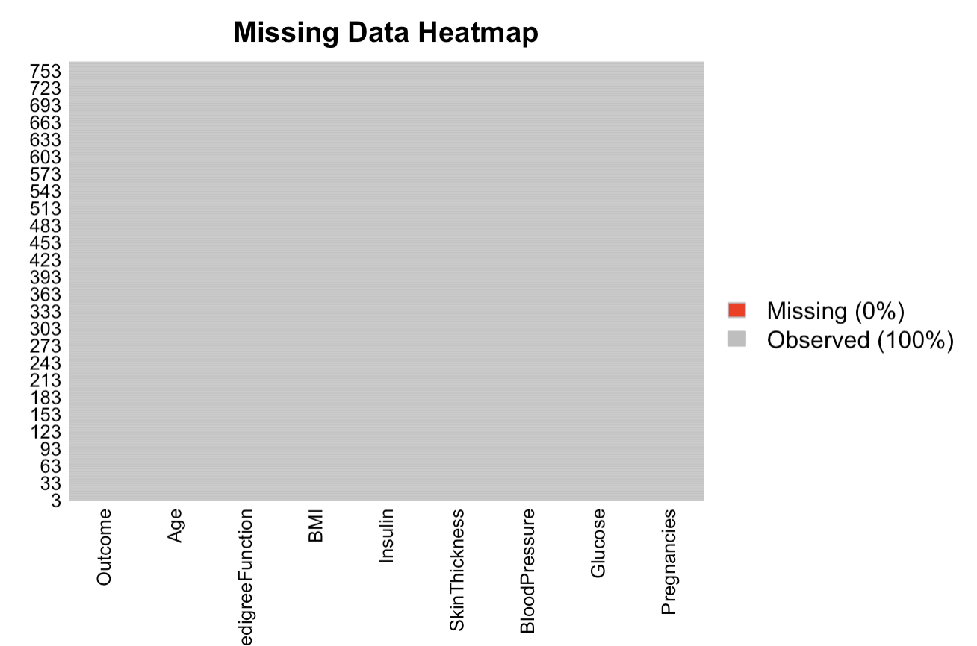
- Class Distribution Bar Chart
The target variable Outcome is imbalanced, with approximately 35% positive (diabetic) and 65% negative (non-diabetic) cases. This class imbalance is visualized through a bar chart, emphasizing the need to consider evaluation metrics like ROC-AUC over accuracy.
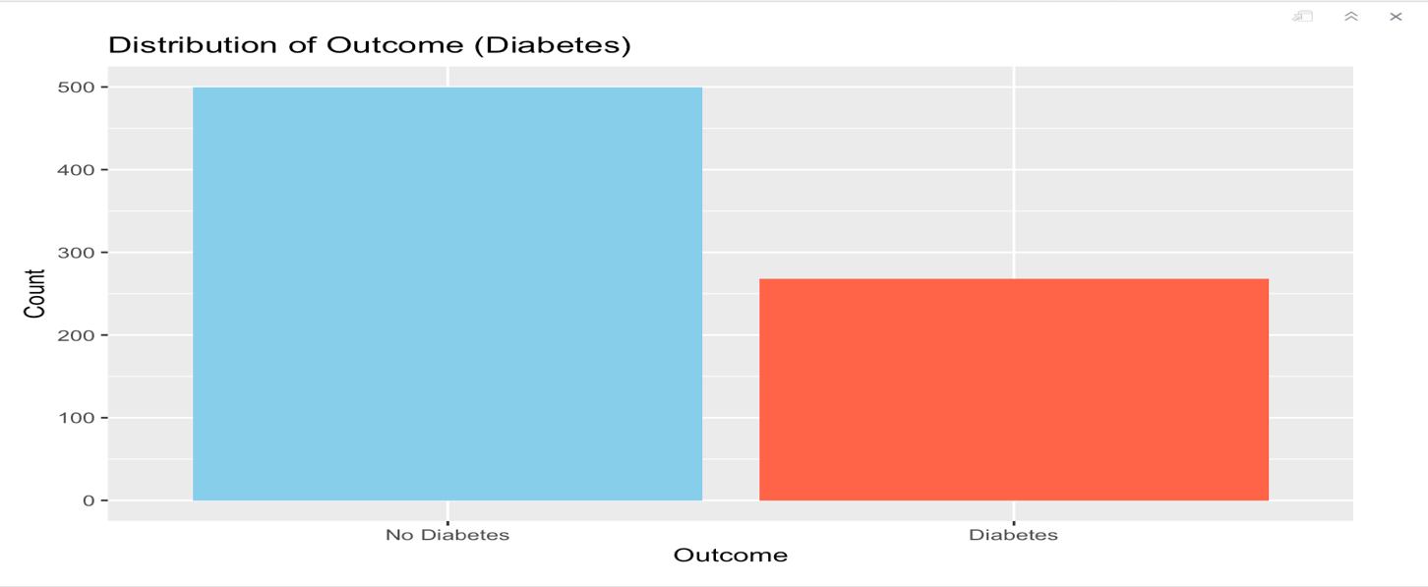
- Feature Distributions:
Histograms and boxplots were generated for all features. Key observations include:

- Glucose and BMI show relatively normal distributions but have different ranges between diabetic and non-diabetic individuals.

- Insulin and SkinThickness have many zero values, suggesting incomplete data.

- Age and Pregnancies show right-skewed distributions, with higher values in diabetic individuals.

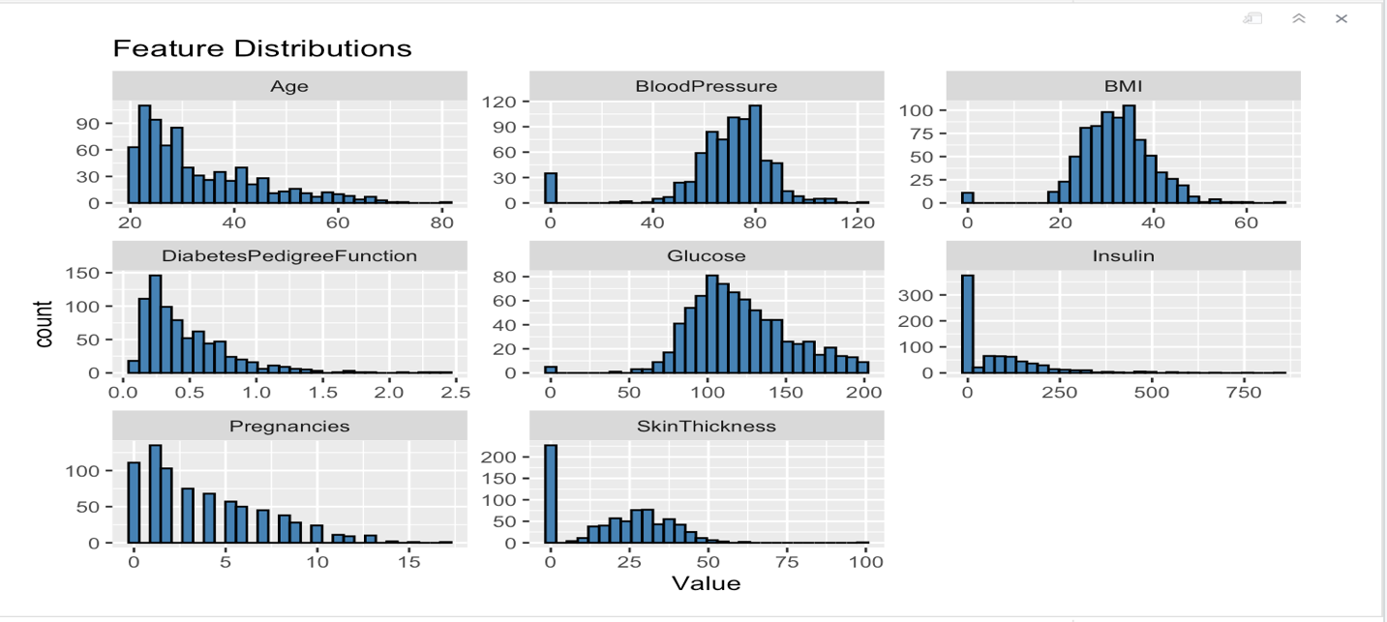
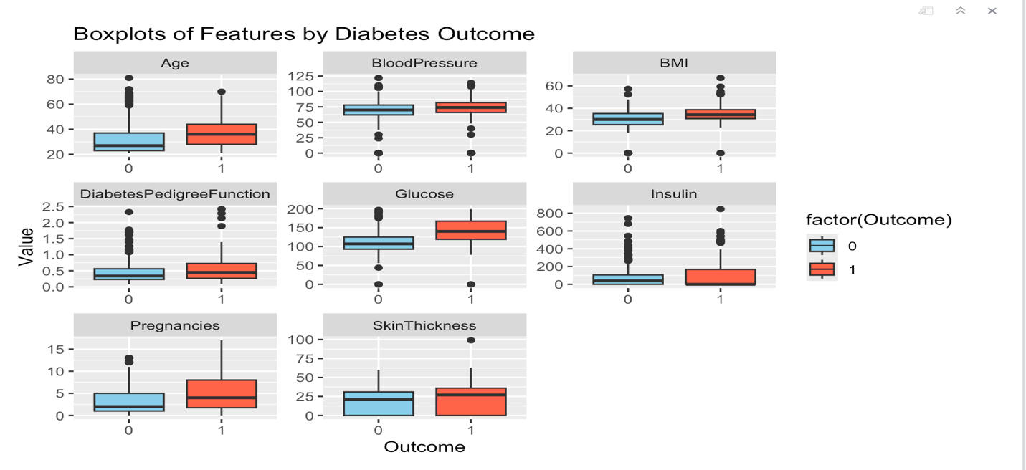
- Correlation Analysis:
A correlation matrix revealed strong positive correlations between:
- Glucose and BMI
- Age and Pregnancies
These relationships help inform feature interactions and modeling strategies.
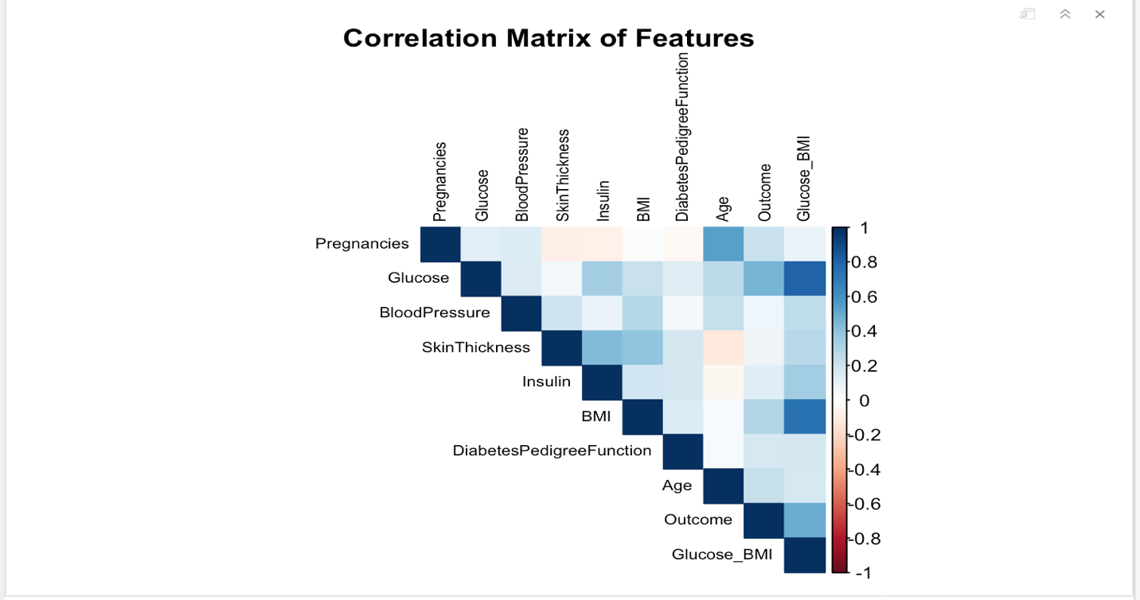
- Feature Relationships:
Scatterplots revealed clear patterns of class separation:
- Diabetic individuals tend to have higher Glucose and BMI.
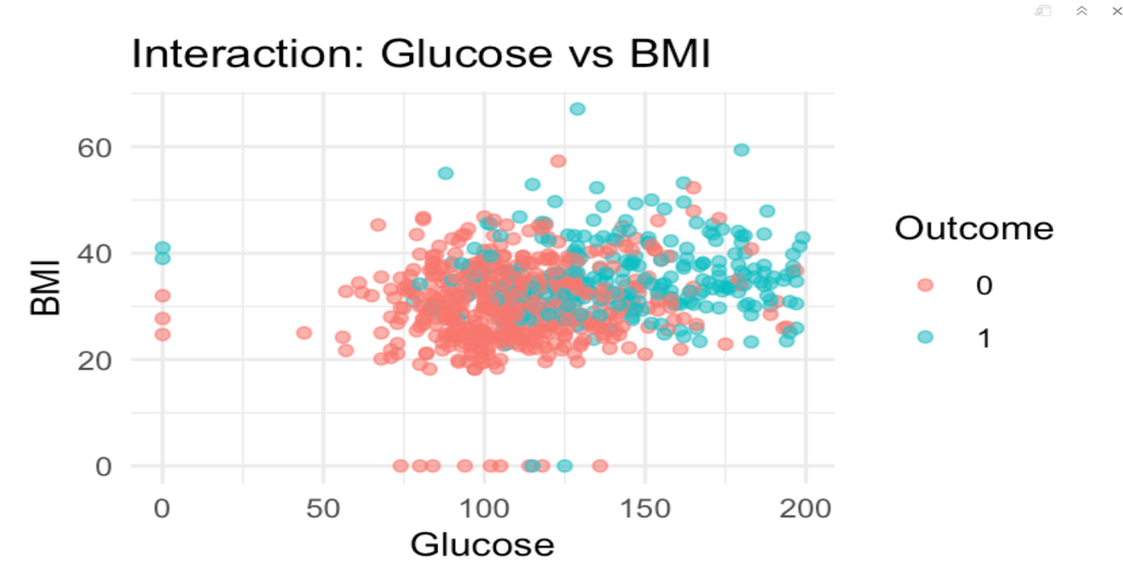
- Older individuals with higher BloodPressure are more likely to be diabetic.
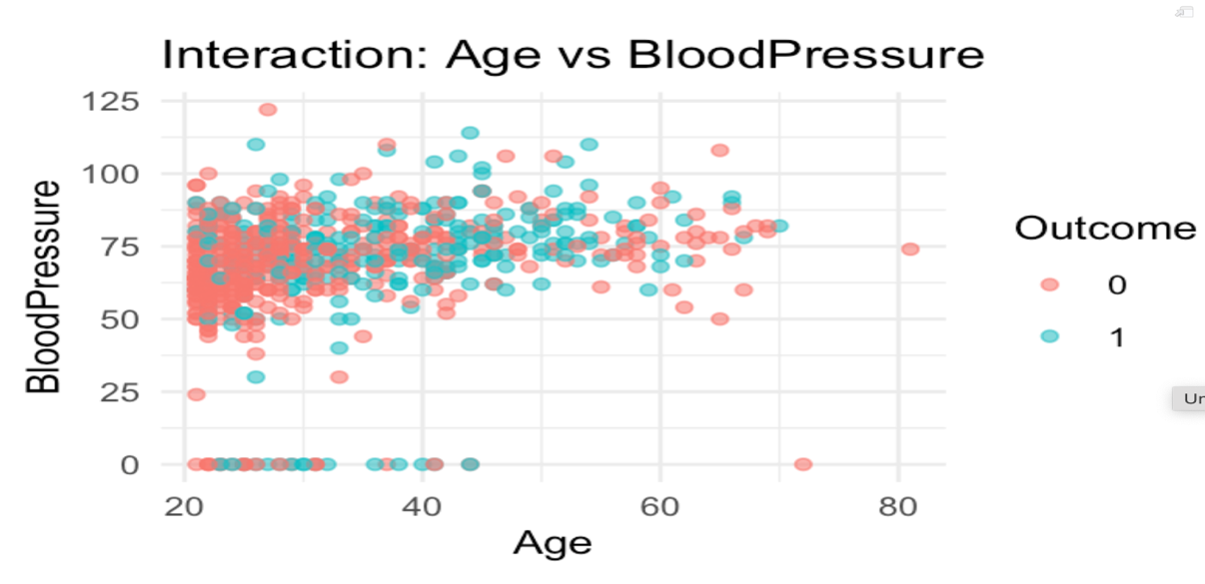
- Pairwise Feature Interactions:
A ggpairs plot illustrated multivariate relationships and class separability. These visualizations confirmed that multiple features together better distinguish classes than individual features alone.

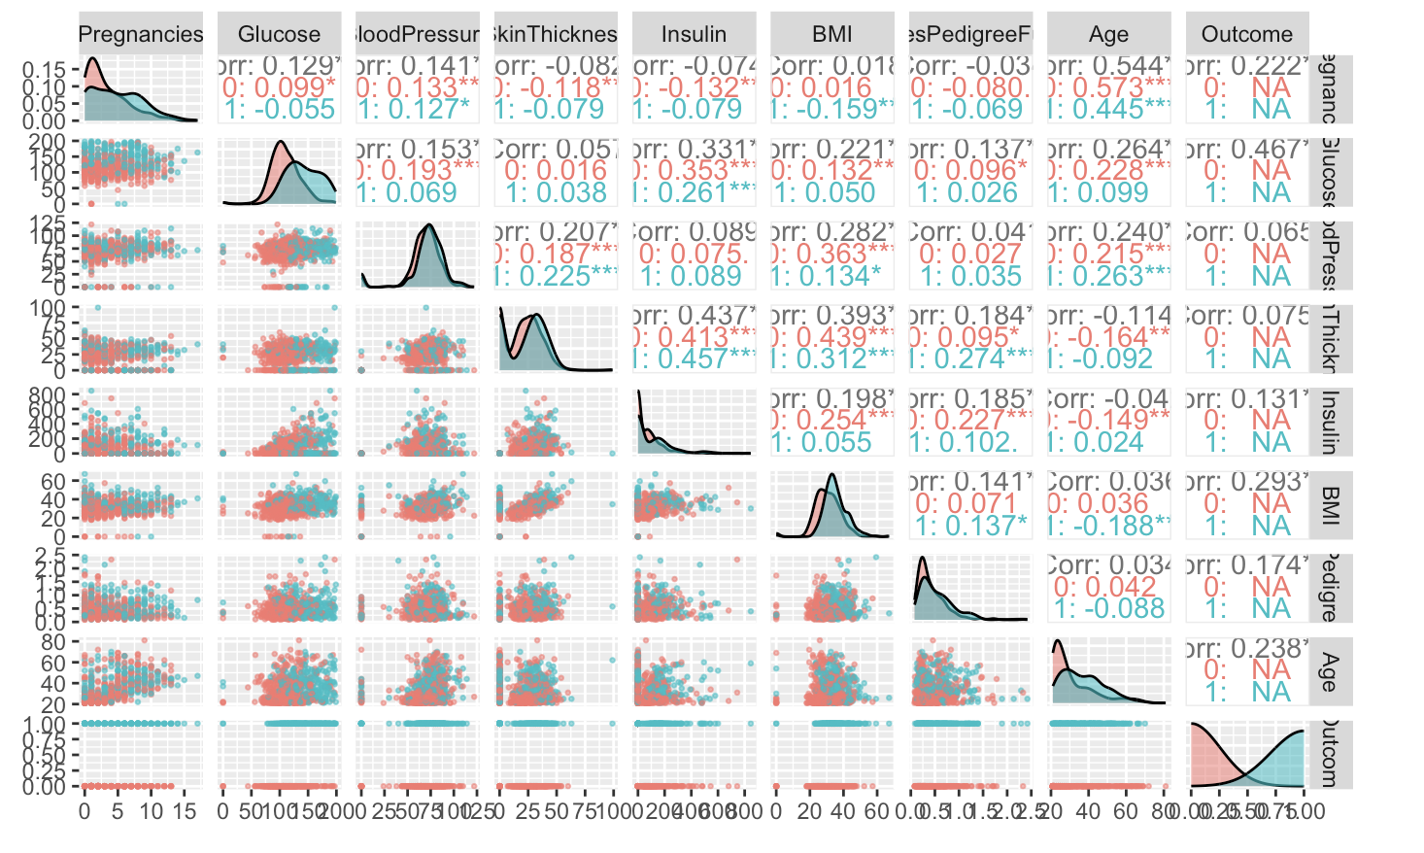

- Feature Engineering:
Interaction terms like Glucose × BMI and Age × BloodPressure were created and later used in model training, improving predictive power.
This EDA step provided foundational insights that shaped preprocessing choices, feature engineering, and model selection.
CASE STUDY: MODEL EVALUATION
Logistic Regression
- Accuracy: 78.4%
- ROC-AUC: 0.850
- Strengths: Easy to implement and interpret.
- Limitations: Assumes linear relationship between predictors and outcome.
Random Forest
- Accuracy: 75.8%
- ROC-AUC: 0.852
- Strengths: Handles missing data and nonlinear interactions well.
- Limitations: Slower in training; less interpretable.
XGBoost
- Accuracy: 79.1%
- ROC-AUC: 0.855 (highest)
- Strengths: High accuracy and handles feature importance well.
- Limitations: Complexity of tuning and interpretability.
SHAP Analysis: SHAP plots revealed that Glucose, BMI, and Age were the top contributors to prediction. This insight is vital for clinicians to focus on the most influential parameters when making diagnostic decisions.
DISCUSSION ON RESULTS
The three models provided similar but distinct performance outcomes. XGBoost showed slightly higher accuracy and ROC-AUC than the other two models. Logistic Regression, despite being simpler, performed competitively and offered better interpretability, making it useful in clinical settings.
Comparison Table:
METRIC | LOGISTIC REGRESSION | RANDOM FOREST | XGBOOST
Accuracy | 78.4% | 75.8% | 79.1%
ROC-AUC | 0.850 | 0.852 | 0.855
Interpretability | High | Medium | Low

Overall, XGBoost's superior metrics combined with SHAP-based interpretability make it a valuable tool for practical deployment.
Visual Results
1.Confusion Matrices
Logistic regression confusion matrix
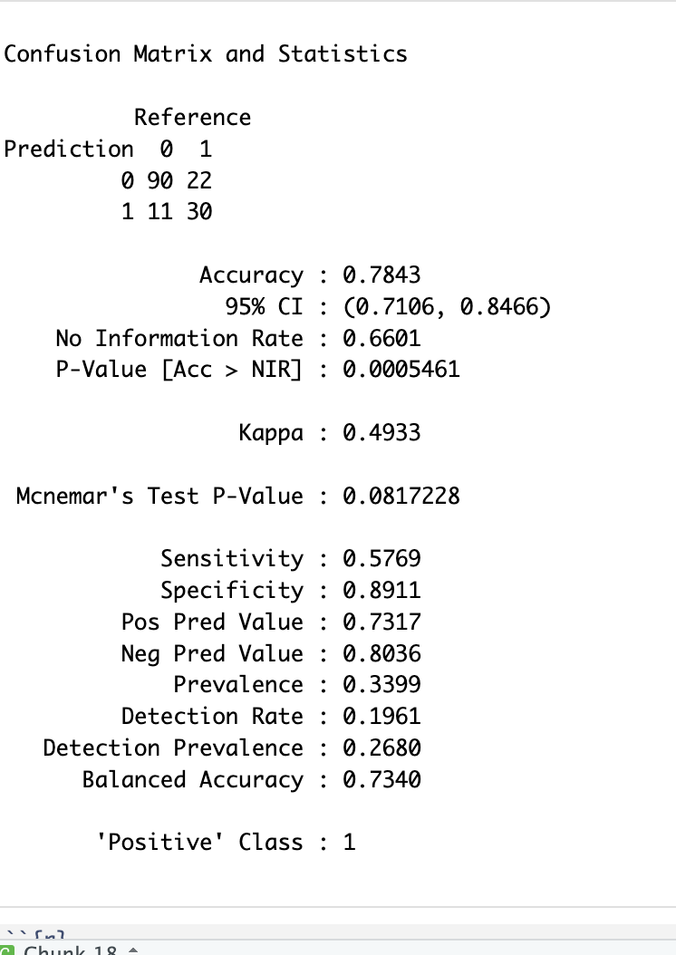

Random Forest confusion matrix
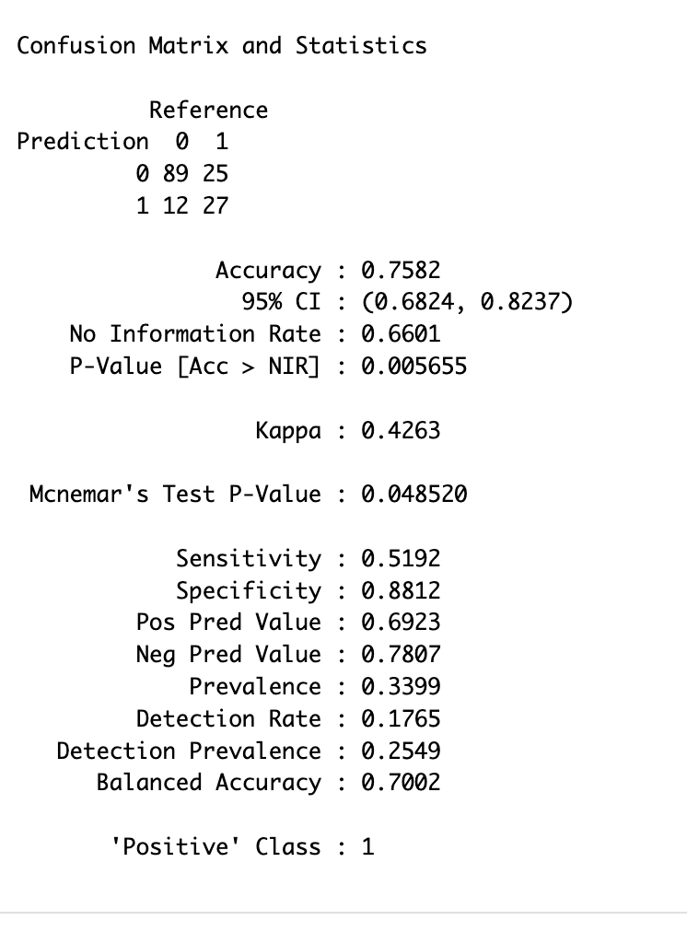
XGBOOST Confusion matrix
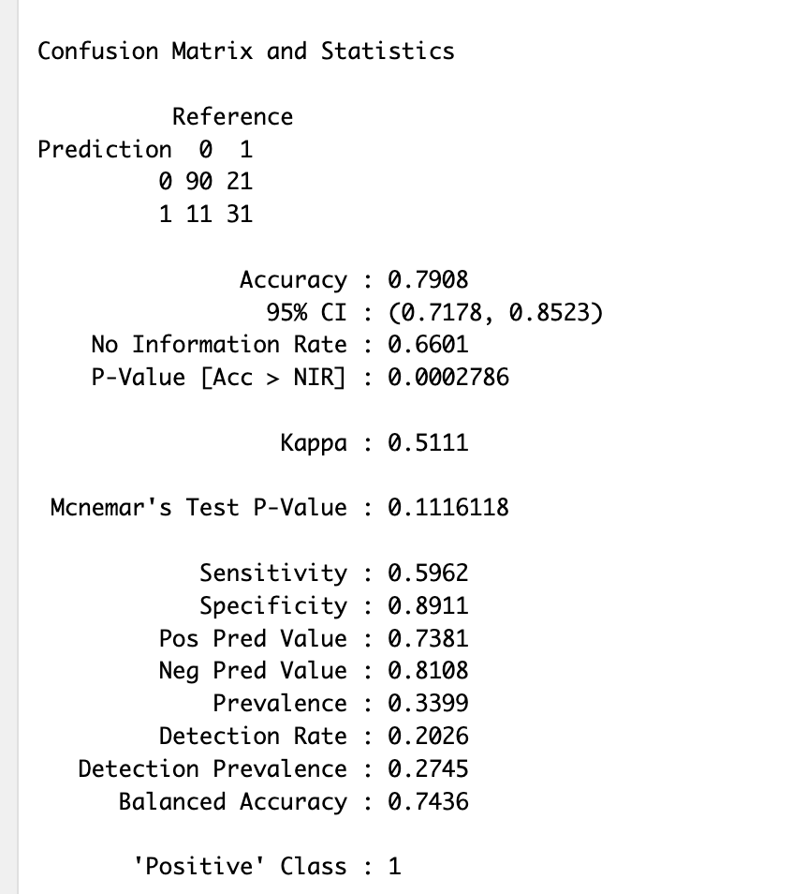

2.ROC Curve Comparison
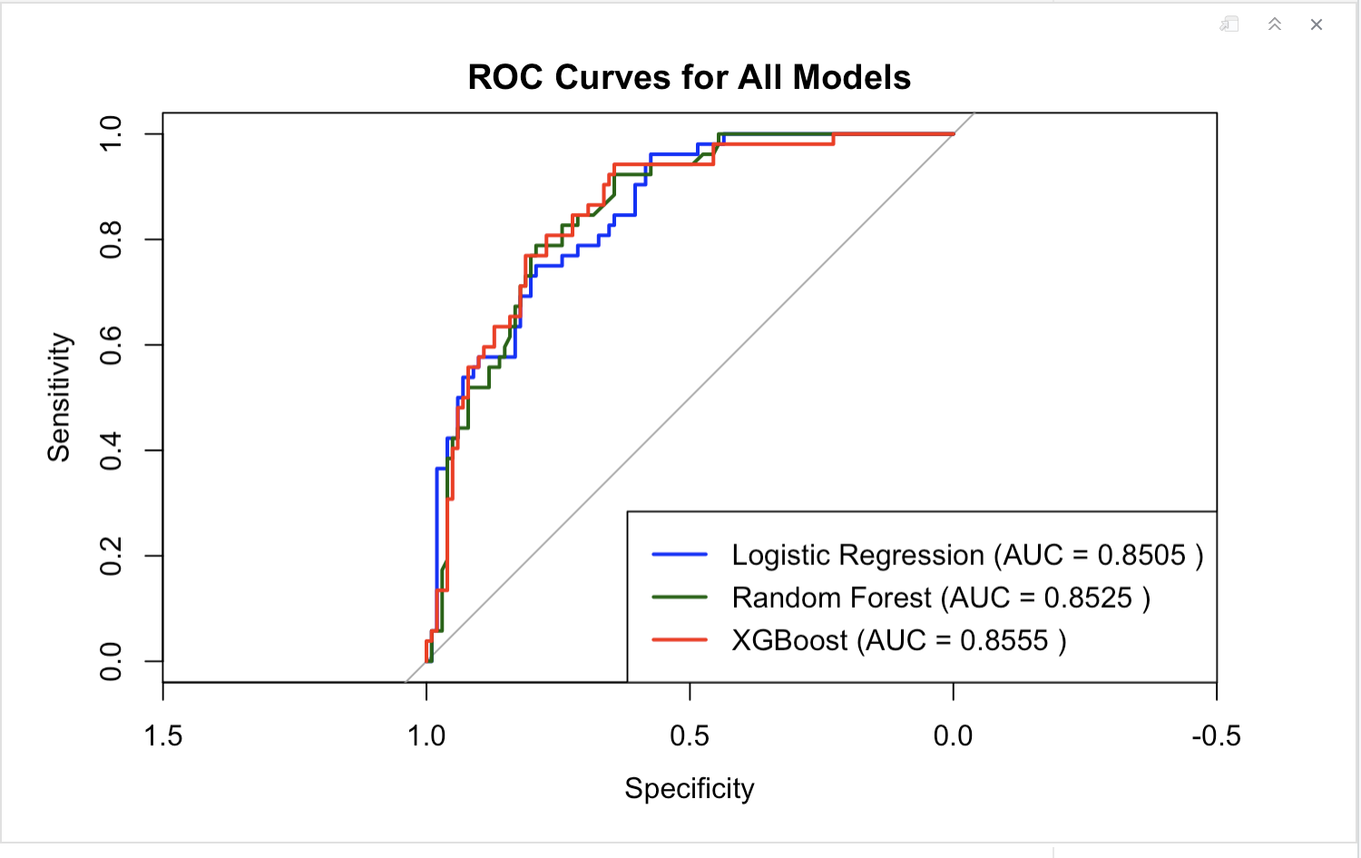
3.Feature Importance
Random Forest Feature Importance
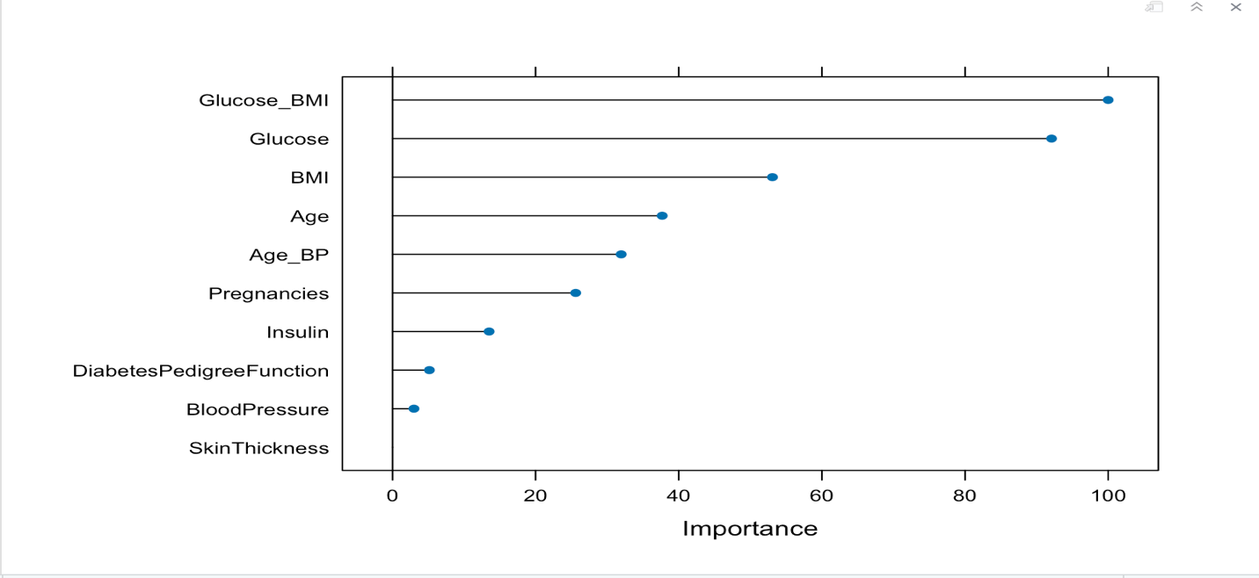

XGBoost Feature Importance
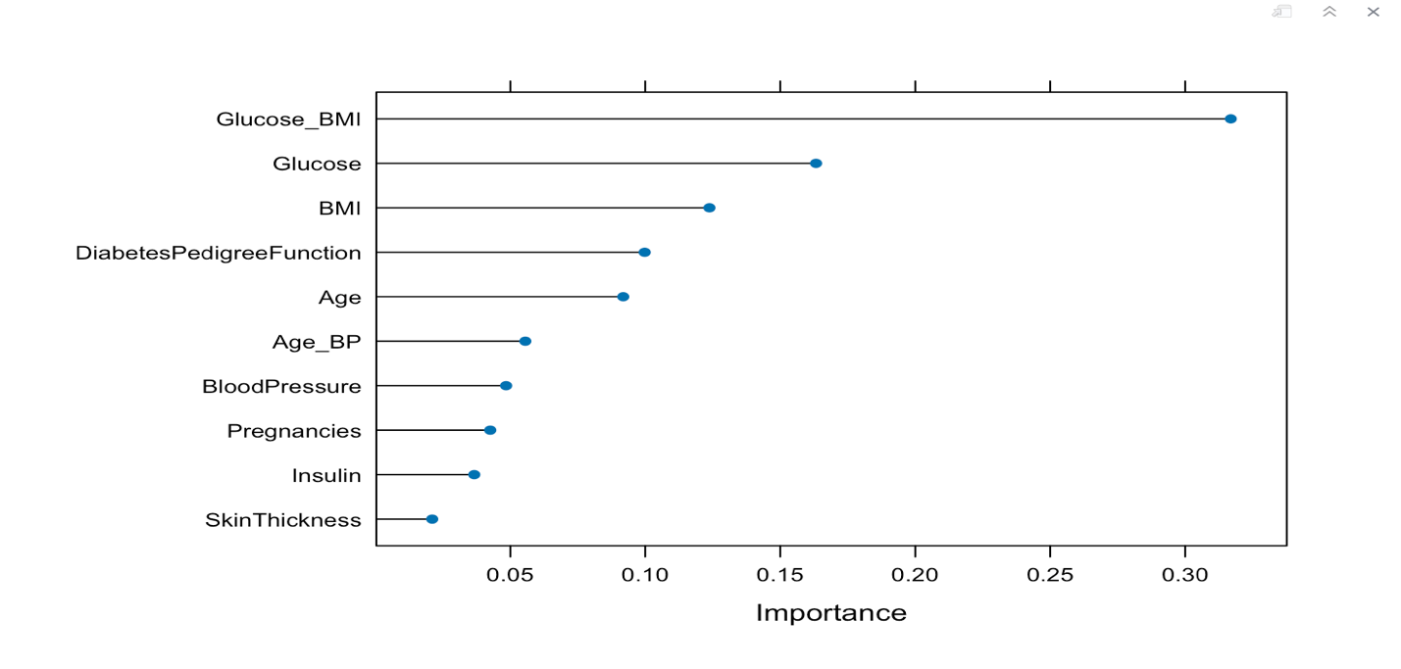
4.SHAP Summary Plot
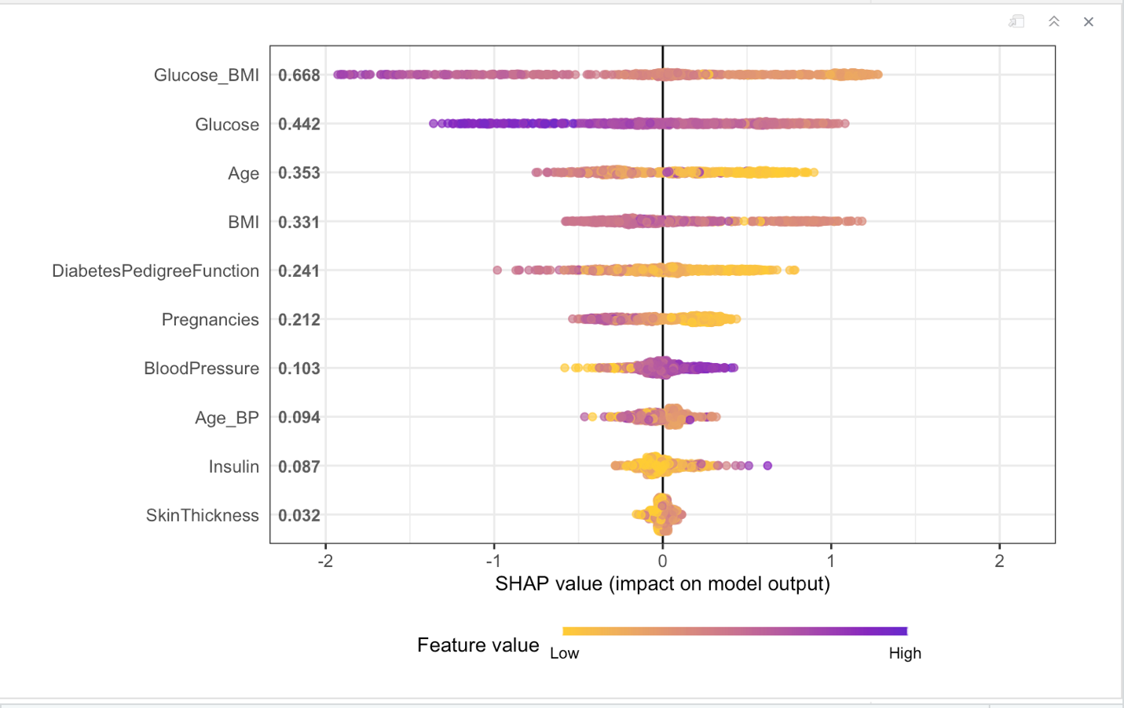
CONCLUSIONS, SUMMARY OF FINDINGS & RECOMMENDATIONS
CONCLUSIONS: All three models—Logistic Regression, Random Forest, and XGBoost—were effective in predicting diabetes. Among them, XGBoost showed the best performance but at the cost of higher complexity.
Findings:
- Glucose and BMI are consistently the most important features.
- SHAP helps in interpreting black-box models like XGBoost.
- Ensemble models outperform linear models but require more computational resources.
Recommendations:
- For clinical decision support tools, use XGBoost paired with SHAP for explainability.
- Where transparency is crucial, Logistic Regression should be used.
- Extend the dataset with lifestyle and family history data for better prediction.
FUTURE WORK
Future directions include:
- Expanding the dataset to include more diverse population samples.
- Incorporating time-based features and patient history.
- Exploring deep learning models for long-term prediction.
- Deploying a web-based application that integrates with clinical databases.
Such advancements would make the system more robust, scalable, and applicable in real-world healthcare environments.
LESSONS LEARNED FROM THE PROJECT
- Proper data preprocessing significantly affects model outcomes.
- Ensemble methods like Random Forest and XGBoost are powerful but require careful tuning.
- ROC-AUC is more reliable than accuracy in imbalanced datasets.
- Tools like SHAP are essential for gaining trust in black-box models.
- Parallel processing is helpful in reducing training time for complex models.
This project reinforced the critical role of machine learning in transforming healthcare from reactive to proactive care.
REFERENCES
- Grinberg, M. (2018). Flask Web Development. O’Reilly.
- https://www.kaggle.com/datasets/uciml/pima-indians-diabetes-database
- Lundberg, S. M., & Lee, S. I. (2017). A unified approach to interpreting model predictions. NeurIPS.
- Chen, T., & Guestrin, C. (2016). XGBoost: A scalable tree boosting system. KDD.
APPENDIX
# Load necessary libraries
library(caret)
library(randomForest)
library(xgboost)
library(dplyr)
library(corrplot)
library(Amelia)
library(ggplot2)
library(GGally)
library(ROCR)
library(SHAPforxgboost)
library(doParallel)
library(pROC)
library(tidyr)
# Load the new dataset
new_diabetes_data <- read.csv("diabetes.csv")
# Check the structure
str(new_diabetes_data)
#summary of the dataset
summary(new_diabetes_data)
missmap(new_diabetes_data, main = "Missing Data Heatmap", col = c("red", "grey"))
# Class balance
ggplot(new_diabetes_data, aes(x = factor(Outcome))) + geom_bar(fill = c("skyblue", "tomato")) +labs(title = "Distribution of Outcome (Diabetes)", x = "Outcome", y = "Count") + scale_x_discrete(labels = c("No Diabetes", "Diabetes"))
# Histogram for all numeric variables
new_diabetes_data_long <- new_diabetes_data %>%
pivot_longer(cols = -Outcome, names_to = "Feature", values_to = "Value")
ggplot(new_diabetes_data_long, aes(x = Value)) +geom_histogram(bins = 30, fill = "steelblue", color = "black") +facet_wrap(~ Feature, scales = "free") +labs(title = "Feature Distributions")
# Boxplots of features grouped by outcome
ggplot(new_diabetes_data_long, aes(x = factor(Outcome), y = Value, fill = factor(Outcome))) +
geom_boxplot() +facet_wrap(~ Feature, scales = "free") +labs(title = "Boxplots of Features by Diabetes Outcome", x = "Outcome") +
scale_fill_manual(values = c("skyblue", "tomato"))
# Pairwise relationships between features and Outcome
ggpairs(new_diabetes_data, aes(color = factor(Outcome), alpha = 0.5),
lower = list(continuous = wrap("points", size = 0.5)))
# --- Feature Interaction Plots ---
# Example 1: Glucose vs BMI
ggplot(new_diabetes_data, aes(x = Glucose, y = BMI, color = factor(Outcome))) +
geom_point(alpha = 0.6) +labs(title = "Interaction: Glucose vs BMI", color = "Outcome") +
theme_minimal()
# Example 2: Age vs BloodPressure
ggplot(new_diabetes_data, aes(x = Age, y = BloodPressure, color = factor(Outcome))) +
geom_point(alpha = 0.6) + labs(title = "Interaction: Age vs BloodPressure", color = "Outcome") +theme_minimal()
new_diabetes_data$Glucose_BMI <- new_diabetes_data$Glucose * new_diabetes_data$BMI
new_diabetes_data$Age_BP <- new_diabetes_data$Age * new_diabetes_data$BloodPressure
# Handle missing values (if any)
preProcValues <- preProcess(new_diabetes_data, method = 'medianImpute')
new_diabetes_data <- predict(preProcValues, new_diabetes_data)
# --- Correlation Matrix ---
cor_matrix <- cor(new_diabetes_data[, -ncol(new_diabetes_data)]) # exclude Outcome column
corrplot(cor_matrix, method = "color", type = "upper", tl.cex = 0.7, tl.col = "black", title = "Correlation Matrix of Features", mar = c(0,0,1,0))
# Feature Scaling
new_diabetes_data_scaled <- new_diabetes_data
new_diabetes_data_scaled[, -ncol(new_diabetes_data)] <- scale(new_diabetes_data[, -ncol(new_diabetes_data)])
# Check for missing values after imputation
sum(is.na(new_diabetes_data))
# Split the data into training and testing sets (80% train, 20% test)
set.seed(123)
trainIndex <- createDataPartition(new_diabetes_data$Outcome, p = 0.8, list = FALSE)
trainData <- new_diabetes_data[trainIndex, ]
testData <- new_diabetes_data[-trainIndex, ]
# Convert Outcome to factor with levels 0 and 1
trainData$Outcome <- factor(trainData$Outcome, levels = c(0, 1))
testData$Outcome <- factor(testData$Outcome, levels = c(0, 1))
cv_control <- trainControl(method = "cv", number = 10)
# --- Train Logistic Regression (no parallel needed) ---
logit_model <- glm(Outcome ~ ., data = trainData, family = binomial)
logit_pred <- predict(logit_model, testData, type = "response")
logit_pred_class <- ifelse(logit_pred > 0.5, 1, 0)
logit_conf_matrix <- confusionMatrix(factor(logit_pred_class), testData$Outcome, positive = "1")
print(logit_conf_matrix)
# --- Train Random Forest (no parallel needed) ---
rf_grid <- expand.grid(mtry = c(1, 2, 3, 4, 5))
rf_model <- train(Outcome ~ ., data = trainData, method = "rf", trControl = cv_control, tuneGrid = rf_grid, importance = TRUE)
rf_pred <- predict(rf_model, testData)
rf_conf_matrix <- confusionMatrix(rf_pred, testData$Outcome, positive = "1")
print(rf_conf_matrix)
# --- Prepare for XGBoost Training ---
xgb_grid <- expand.grid(nrounds = 50, max_depth = 4, eta = 0.1, gamma = 0, colsample_bytree = 0.8, min_child_weight = 1, subsample = 0.8)
# Start parallel processing
cl <- makeCluster(detectCores() - 1)
registerDoParallel(cl)
print("Starting XGBoost training...")
# --- Train XGBoost ---
xgb_model <- train(Outcome ~ ., data = trainData, method = "xgbTree", trControl = cv_control, tuneGrid = xgb_grid)
# Stop parallel processing properly
stopCluster(cl)
stopImplicitCluster()
registerDoSEQ()
print("XGBoost training complete.")
# --- XGBoost Predictions ---
xgb_pred <- predict(xgb_model, testData) # Already class labels
xgb_conf_matrix <- confusionMatrix(xgb_pred, testData$Outcome, positive = "1")
print(xgb_conf_matrix)
# --- Error Analysis ---
misclassified <- testData %>%
mutate(Predicted = xgb_pred) %>%
filter(Predicted != Outcome)
head(misclassified) # Show first few misclassified cases
# --- ROC-AUC Calculations ---
# Logistic Regression ROC-AUC
logit_roc <- roc(testData$Outcome, logit_pred)
cat("Logistic Regression ROC-AUC: ", auc(logit_roc), "\n")
rf_prob <- predict(rf_model, testData, type = "prob")[,2]
rf_roc <- roc(testData$Outcome, rf_prob)
cat("Random Forest ROC-AUC: ", auc(rf_roc), "\n")
xgb_prob <- predict(xgb_model, testData, type = "prob")[,2]
xgb_roc <- roc(testData$Outcome, xgb_prob)
cat("XGBoost ROC-AUC: ", auc(xgb_roc), "\n")
# --- Model Performance Comparison ---
model_perf <- data.frame(
Model = c("Logistic Regression", "Random Forest", "XGBoost"),
AUC = c(auc(logit_roc), auc(rf_roc), auc(xgb_roc)))
ggplot(model_perf, aes(x = Model, y = AUC, fill = Model)) +
geom_col() + labs(title = "Model ROC-AUC Comparison", y = "AUC Score") +
theme_minimal()
# --- ROC Curves Plot with AUC Values ---
plot(logit_roc, col = "blue", lwd = 2, main = "ROC Curves for All Models")
lines(rf_roc, col = "darkgreen", lwd = 2)
lines(xgb_roc, col = "red", lwd = 2)
logit_auc <- round(auc(logit_roc), 4)
rf_auc <- round(auc(rf_roc), 4)
xgb_auc <- round(auc(xgb_roc), 4)
legend("bottomright",
legend = c(paste("Logistic Regression (AUC =", logit_auc, ")"),paste("Random Forest(AUC =",
rf_auc, ")"), paste("XGBoost (AUC =", xgb_auc, ")") ),col = c("blue", "darkgreen", "red"),
lwd = 2)
# --- Feature Importance ---
rf_imp <- varImp(rf_model)
plot(rf_imp)
xgb_imp <- varImp(xgb_model, scale = FALSE)
plot(xgb_imp)
# --- SHAP Analysis for XGBoost ---
library(SHAPforxgboost)
# Convert data to matrix format as required
train_matrix <- model.matrix(Outcome ~ . -1, data = trainData)
test_matrix <- data.matrix(testData[, -ncol(testData)]) # Exclude Outcome
# Extract the trained xgboost model object
xgb_final_model <- xgb_model$finalModel
# Calculate SHAP values
shap_values <- shap.values(xgb_model = xgb_final_model, X_train = train_matrix)
# SHAP summary plot
shap_long <- shap.prep(shap_contrib = shap_values$shap_score, X_train = train_matrix)
shap.plot.summary(shap_long)
# --- Summary Table of ROC-AUC Scores ---
model_names <- c("Logistic Regression", "Random Forest", "XGBoost")
roc_aucs <- c(auc(logit_roc), auc(rf_roc), auc(xgb_roc))
roc_summary <- data.frame(Model = model_names, ROC_AUC = round(roc_aucs, 4))
print(roc_summary)

